Experiments (6 to 10)
Name:M.Vishnu Vardhan Reddy
Reg.no:192325061
Course Code:Ita0345
6.Create an R list containing vectors, matrices, and functions; display contents.
my_list <- list(
vector1 = c(1,2,3,4,5),
matrix1 = matrix(1:9, nrow=3),
function1 = function(x) x^2
)
print(my_list)
print(my_list$vector1)
print(my_list$matrix1)
print(my_list$function1(5))
output
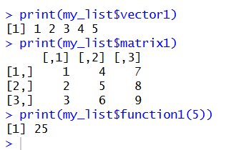
7. Write R programs for basic tasks: Factors of a number, generate a vector of 10 random integers between -50 and 50, print numbers 1–100 with FizzBuzz logic.
num <- 12
for(i in 1:num){
if(num %% i == 0){
print(i)
}
}
sample(-50:50, 10)
for(i in 1:100){
if(i %% 15 == 0) print("FizzBuzz")
else if(i %% 3 == 0) print("Fizz")
else if(i %% 5 == 0) print("Buzz")
else print(i)
}
Output
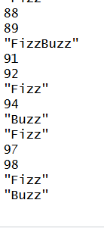
8. Generate random numbers from a normal distribution; count occurrences.
x <- rnorm(1000, mean = 0, sd = 1)
summary(x)
table(cut(x, breaks=5))
output
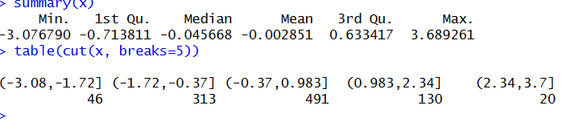

9. Create empty plots with specified axis limits.
plot(1, type="n", xlim=c(0,100), ylim=c(0,50),
xlab="X-axis", ylab="Y-axis",
main="Empty Plot")

Output
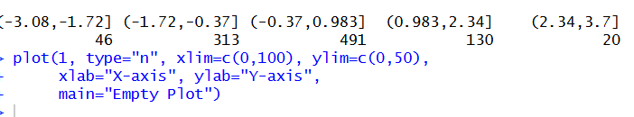

10. 10. Create and explore a data frame exam_data with name, score, attempts, and qualify fields. Perform extract, add row/column, sort, save to file.
exam_data <- data.frame(
name=c("A","B","C","D","E"),
score=c(90,85,88,92,75),
attempts=c(1,2,1,3,2),
qualify=c("yes","yes","yes","yes","no")
)
print(exam_data)
exam_data[1:3,]
exam_data$grade <- c("A","B","B","A","C")
exam_data <- rbind(exam_data, data.frame(name="F",score=80,attempts=1,qualify="yes",grade="B"))
exam_data <- exam_data[order(-exam_data$score),]
write.csv(exam_data,"exam_data.csv",row.names=FALSE)
output
